DAC Circuit Simulation Using R-2R Ladder Network
  - ENGS152 Circuits Lab
7 February 2026

Schematic
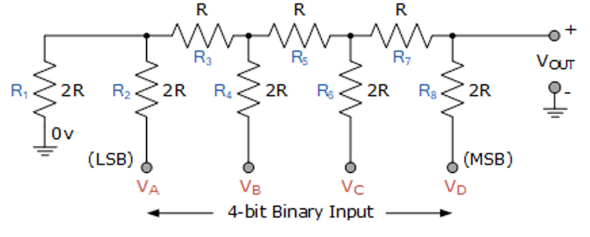

Introduction
DAC (Digital to Analog Converter) is a special circuit that allows you to convert digital signals to analog. $V_{A}$ to $V_{D}$ pins are binary inputs of the 4-bit DAC. The input pins are either connected to 5V, either to the ground, correspondingly 0 and 1. The output voltage is determined by the combination of the input voltages.
$$V_{out}=V_{ref}×\frac{D}{2^{n}}$$
The resistance values of 10 k$Ω$ and 20 k$Ω$ were chosen randomly, however the one to two ration was kept. One can estimate the maximum current that could flow in the circuit, assuming that only MSB is connected to 5 V, and other terminals are connected to the GND. This creates the combination of the lowest resistance in the circuit and allows more current to flow in the circuit.
$I_{m}=\frac{V_{ref}}{2R}$ = 0.25 mA, for $V_{ref}=5V$ and R = 10 kΩ.

